Software Update Guide

How to update the HMD software system?
- Online update:
- Connect headset to the Internet.
- App -> System Update (as shown below).
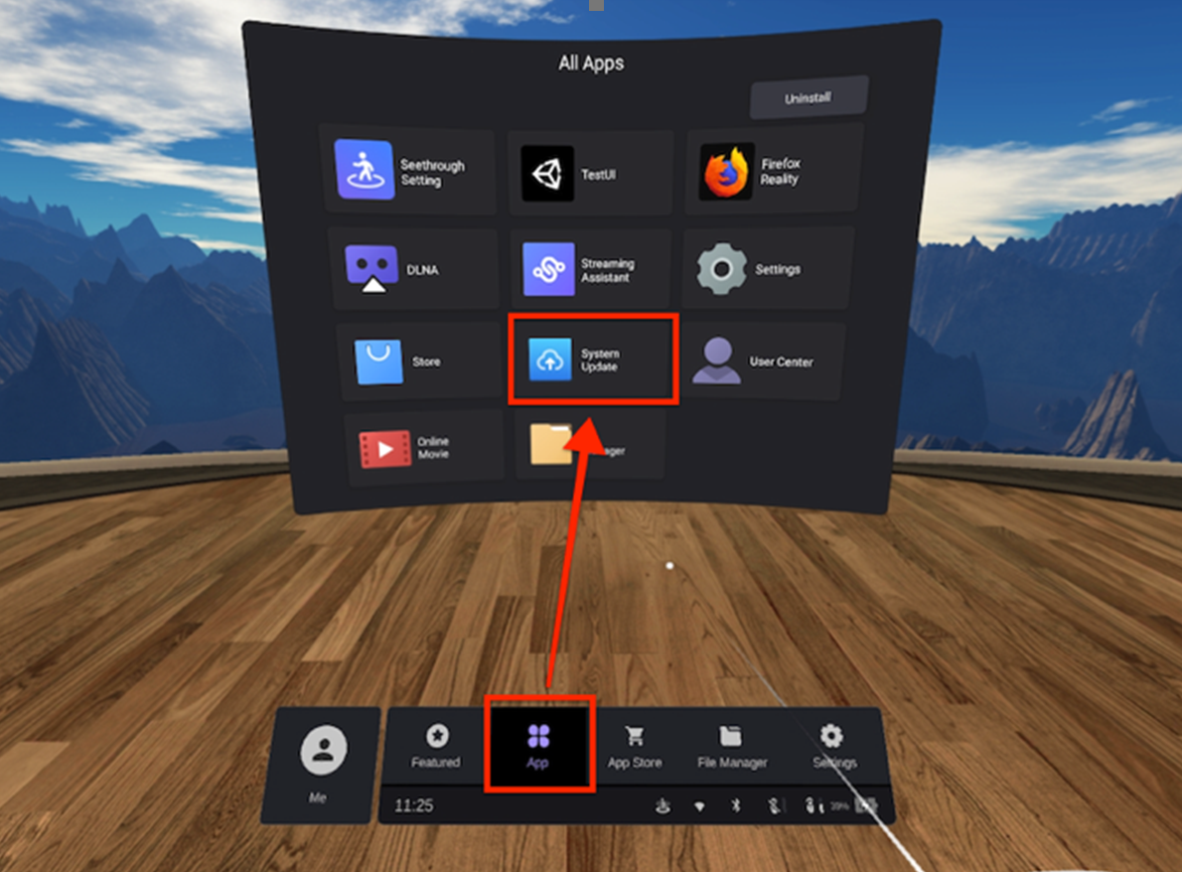
- Offline update:
- Create a new “dload” folder in the root directory of the device storage, and copy the offline update .zip package into it (as shown below).
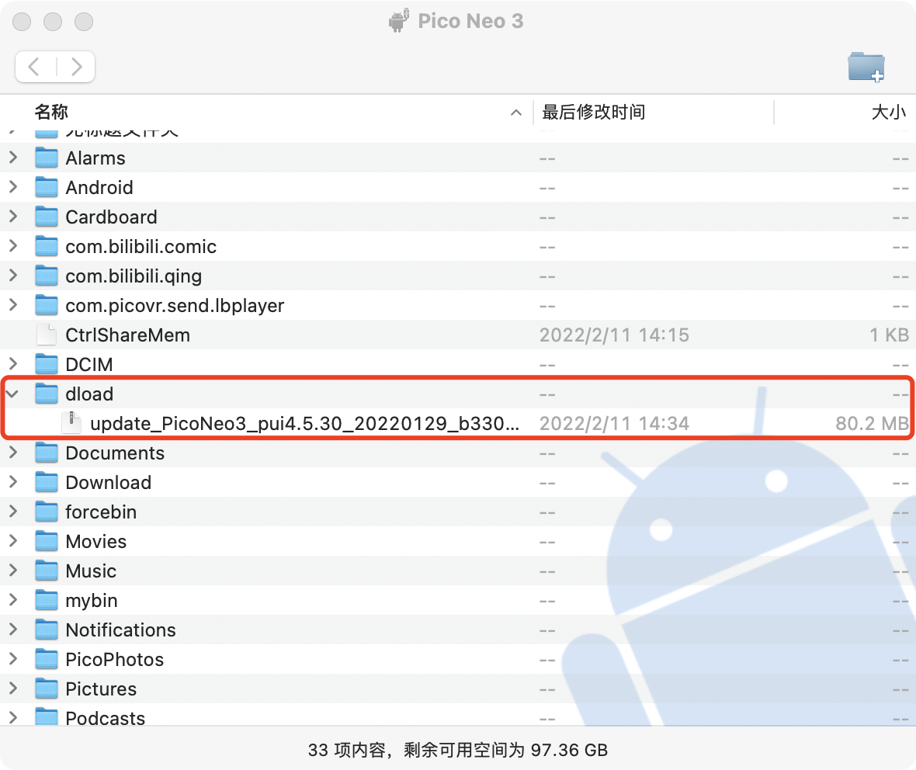
- App -> System Update -> Offline update

